
Autumn Newsletter 2026
“The best of all rains is the rain that comes after the worst of all droughts” Proverb / Folk law
Hello fellow gardeners, Well, what a summer it has been. For those in the UK who don’t have a garden, live near a beach and like sunbathing, sailing, water skiing or any other water sport, the summer of 2026 has definitely been right up their street. I suspect though, that most of our membership found the heat waves intolerable and were greatly upset to see beloved plants suffering in the high temperatures and arid conditions. We were warned heat waves would be more frequent but we ‘brits’ always seem to take little notice of what the forecasters are telling us and pretend our gardens will ‘pull through’. Some have not. I have seen dying plants in many gardens, and desperate owners at a loss to know what to do to protect their favourite cultivars when the hosepipe bans came into force. We know the heat waves are likely to happen again next year so we do need to think about how to ‘future proof’ our plots – and make changes. There are things we can do to help plants get through heat and drought. Everything we grow really only depends upon two things: water and the soil. Installing one or more water butts to collect every drop of rain is a good idea. Another is to feed our soil. I know I have, at every opportunity in my Newsletters and at the society meetings, advocated ‘going organic’ and that we should ‘feed our soil not our plants’. Never has there been a time when doing this has been more important. Putting organic matter into the soil not only ‘feeds’ it but greatly improves its water holding properties. Soil is made up of 50% mineral material and organic matter, 25% air and 25% water! Mulching it locks in that moisture, making it less likely to dry out quickly. Of course to aid this we need to purchase organic matter but it will cost us far less if we make our own compost and make plenty of it. If you want to grow a range of plants that have the capacity to withstand drought, improving the soil is absolutely vital. Even though I practice what I preach looking round my garden highlighted plants that survived remarkably well BUT also those that suffered. Everything in the Mediterranean Garden, as one would expect, came through the summer. Here, the hylotephiums, sages, salvias, heucheras and succulents revelled in the heat, but there were some surprises in the other parts of the garden. The shrub, Fatsia japonica actually put on growth and the Caryopteris clandonensis ‘Pink Perfection’ that I planted in a south west facing position has looked the picture of health all summer. Caryopteris clandonensis ‘Worcester Gold’ with blue flowers is also drought tolerant. For a sheltered position I may consider planting Blupleurum fruiticosum which is totally drought resistant too but also tolerates winter wet conditions (always a good characteristic!) Achillea ‘Moonshine’ outshone its neighbours, the Phlox and Anthemis, both of which suffered in their different ways. The phlox flowered well but wilted badly. The Anthemis ‘E.C. Buxton’ remained upright but bore very few of its lovely yellow daisies. Berginias have lasted too. Overall, there were fewer flowers, less growth and bleaching of large - leaved specimens.

Changing the plants we grow to those that relish the heat is an option and using drought tolerant cultivars will certainly make life a lot less stressful. Any silver/ grey or glaucous leaved plant will fit the bill. Plants with microscopic hairs, waxy coatings or air pockets in leaves reflect intense sunlight, reduce water loss and lower leaf temperatures making these plants very suitable for hot dry conditions. Artemisia, Balotta, Brachyglottis, Erygium, Ruta, Lavender, Nepeta, Stachys, Lychnis are a few genus that are drought tolerant. The Artemisia genus includes a number of cultivars that are very useful. Artemisia ‘Powis Castle’ is a nice, neat woody based shrubby perennial that has beautiful finely cut silver foliage. It can succumb to winter cold but is easy to strike from soft wood cuttings taken in late summer. Artemisia absinthium ‘Lambrook Silver ‘looks similar. Artemisia ludoviciana ‘Valerie Finnis’ and A.L. ‘Silver Queen’ are both very upright and semi-evergreen. The leaves are much more pronounced and jagged. I do like Artemisia pontica. Requiring very well drained soil it looks good at the front of the border in quantity. Stachys byzantina is another stalwart eminently suitable for use in this context. I will be planting more Eryngium and Euphorbia next year. Both these are drought tolerant and the ones I already have in the garden have done well (always good to go with what one knows will work)
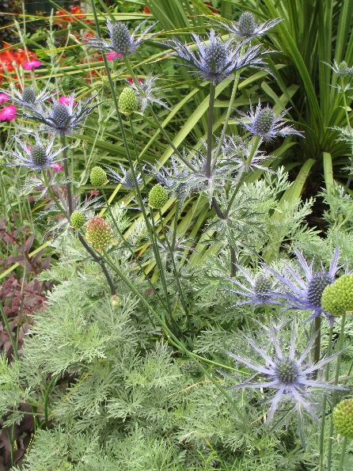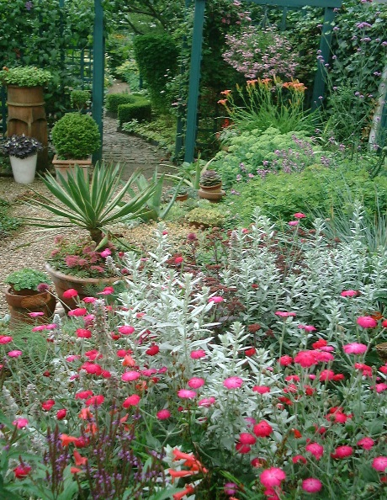
A. ‘Powis Castle’ with Erygium ‘Cobalt Star’ Artemisia luoviciana ‘Valerie Finnis’
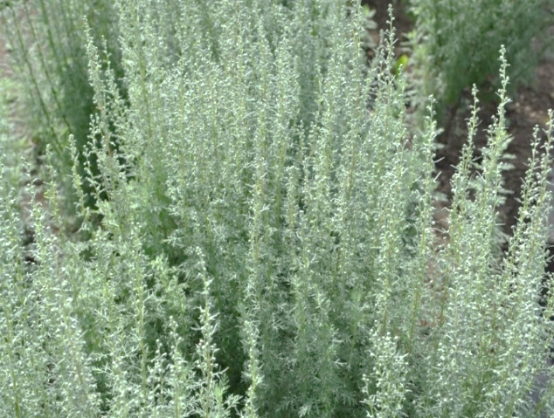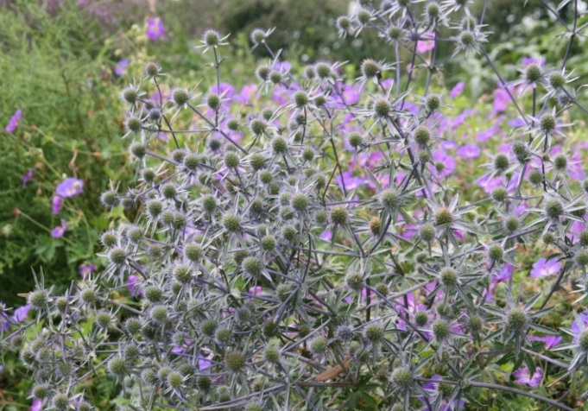
Artemisia pontica Eryngium tripartitum with Geranium ‘Rozanne’
Eryngium tripartitum and Erygium bougatii are front of the border varieties whilst Erygium Planum is better in the middle. All are very useful for their see- through qualities as well as their drought resistance. Another class of plants that tolerate drought are deep rooted ones. Peony, Baptisia, Limonium, Crambe, Gaura, Gypsophila and Thalictrum are some. Once established these will survive because they will have sent their thick tap roots down into the soil to search for water. Of course you will need to ensure that all are watered well until they are and note that it is best if you don’t try to dig them up or move them – they won’t like this at all and may die! There are far too many plants that fit the bill to put in this newsletter but I hope I have whetted your appetite for drought tolerant plants. Doing a little research of our own broadens the mind and inspires don’t you think? Making a few changes to our gardens will, I am sure, makes us feel a whole lot better too when the ‘heat is on’.
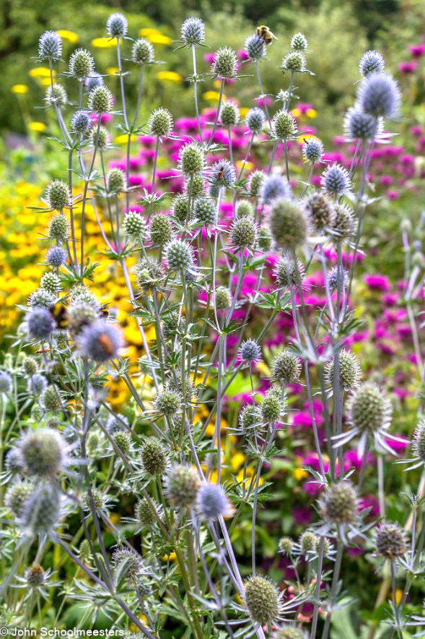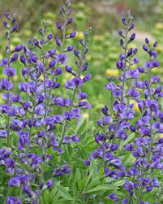
Eryngium planum Baptisia Autralis
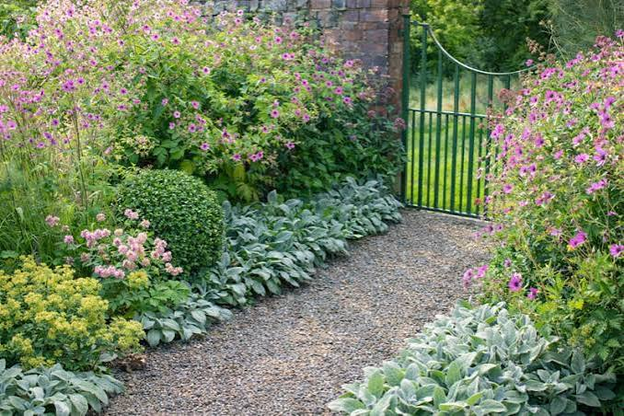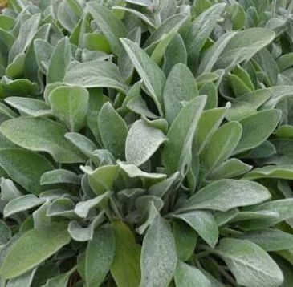
Stachys byzantina

Now that the rain has finally arrived we can be getting on with the usual practical jobs of autumn – picking our produce and tidying up. It is amazing how little time it takes for a garden to get untidy particularly after work is temporarily curtailed because of the high temperatures! Now’s the time to get our fresh air and exercise so to speak. While the weather is still warm in September there is time to get out and about. The autumn shows at Harrogate and Malvern will be beckoning us. They certainly will be an opportunity for me to spend a good day out looking at what is available buying some of the new plants I intend to put into my (hopefully) future drought proof garden! When colder days come beds and borders will need cutting back and hedges given their last cut. Summer bedding will need removing and spring flowering plants planted. All tender species, including succulents and summer flowering bulbs should be bought in under cover to dry out before the onset of colder days. You can take cuttings of pelargoniums now and hard wood cuttings of favourite cultivars. Ponds will need netting too to stop leaves blowing in. Make leaf mould with all the leaves and compost with everything else. I don’t clear all my garden in autumn, but leave the coldest areas untouched until spring, giving the birds and other creatures something to eat during leaner times. What I will definitely be doing to areas cleared is to cover it with enough of the necessary organic matter that is going to keep the soil fertile and moisture retentive and my plants happy during the future heat waves that have been forecast for 2027!
Ben Preston, our speaker for September 15th has been making a few changes of his own too and he will be telling us about them in his talk “Cliff bank Nursery –A New Chapter” At our October meeting (October 20th) we welcome Don Billington who will be talking about “Growing Bromeliads at home”. To finish the autumn programme Marguerite Hughes will be illustrating “Winter – A Season of surprises” for us on November 20th. I am sure all will be very interesting talks to take our minds off the physical work of gardening.
Just one more thing……………. I know it has not been a good year for our gardens and looking after them hasn’t been easy. However, if you are anything like me you will have still been watering the Kitchen Garden and keeping alive all the produce you invested time and energy raising from seed sown in spring. I am sure you will have flowers, fruit or vegetables worthy of showing so why not enter them into the society’s annual Flower Show to be held at Euxton Parish Church Community centre on September 5th? Having a Flower Show that is successful is even more important in a ‘difficult’ year so please make the effort and enter something. Taking part by entering one or two classes puts a totally different perspective on the event. It won’t break the bank either as each entry will only cost 30p! You will need to get your entry form in no later than Wednesday preceding the show. Late entries are allowed up to 6pm on the Friday before the show. If you really can’t find anything remotely suitable you can still come along on the show date and have a lovely time evaluating everyone else’s efforts!
Look forward to seeing you at the Flower Show and……….
Happy gardening
Moe
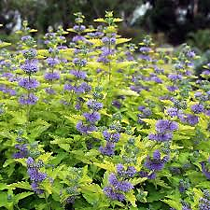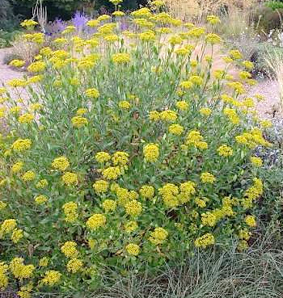
Caryopteris clandonensis ‘Worcester Gold’ Bupleurum fruiticosa
‘

