

Summer Newsletter 2026
“You might think we are nurturing our garden, but of course it is our garden that is nurturing us” Jenny Uglow
Hello fellow gardeners, I hope this newsletter finds you all fit and well although as it happens I am nursing an injury to my leg which has occurred after a run in with a compost bin lid. It won’t put me off going out into the place that I love the most – the garden! Accidents happen from time to time but in the great scheme of things the benefits of being outside far outweigh the disadvantages. As committed gardeners we are fully aware of the impact gardening has on our well – being (most of the time!). With the publicity recently given over to preserving our native plants and creatures we also know how important it is to take care of these too. Have you been watching David Attenborough’s programmes on BBC about wildlife in our gardens? They have been most engaging and I am sure that, although we don’t all possess gardens as big as those featured in the programmes, we get our fair share of ‘wildlife’ in our plots. I know I have, although the otters have eluded me! However…. I have been reliably informed that they have been seen swimming in the River Mersey close to where I live. The ponds I have made in the garden are not substantial enough to accommodate otters but fish, frogs, toads, newts, dragonflies, damsel flies, diving beetles, pond skaters, butterflies, moths and many birds ( I have even seen a kingfisher) like and must have water. These creatures all help keep a healthy balance in the garden, some consuming the ‘pests’ that eat our crops, others pollinating our flowers. Our speaker on July 21st George Pilkington, will be enlightening us further about “Encouraging wildlife in your garden” and I am sure it will be very interesting to hear what he has to say. As I have advocated in past newsletters, we don’t have to turn our gardens into wildernesses in order to attract other creatures to it (I am gratified to notice that the RHS has put this idea to bed now) – we just need to include a diverse range of plants. Always included in mine for summer are bulbs. These add impact to the pot displays and borders. In her talk “Bulbs for the garden throughout the year” on June 16th, Sarah Millington from Hillview Hardy Plants will no doubt mention many that can be grown in summer as well as those for the rest of the year but you might like to be reminded of a few here! One of my favourites is Eucomis. Eucomis, is often referred to by its’ common name, the pineapple flower, because of its’ distinctive structure. I have grown these for many years because they add drama to the garden. I have had losses - mainly due to very cold conditions in winter months, but this hasn’t put me off growing them. Many of the bigger flowered types come from huge bulbs and need very large pots in which to grow them. All need full sun, a good soil based compost, regular feeding and watering to flower well in late summer. The green flowered Eucomis pole evansii is the largest of the varieties available reaching a metre high but most of the others grow from 40cm to 60cms high. Eucomis ‘Sparkling Burgundy’ has very dark foliage and is stunning when in flower, its’ fleshy basal leaves complementing the dense spikes of starry flowers that look just as good when they go to seed. Eucomis ‘Joy’s Purple’ is similar but doesn’t have dark foliage. Eucomis comosa flowers later in the season. It has white flowers and stands 30cms high. Eucomis ‘Nani’ is fairly new on the market and has a height of 25cms but is not as popular as the larger varieties. None are hardy so bulbs need to dry out before winter sets in to prevent them rotting off. I take my pots into the greenhouse in late autumn and raise them up off the ground using pot feet. I let the foliage die down naturally and only tidy them up when I know they have dried completely. Pulling the stems out of the pots damages the bulbs. These bulbs aren’t cheap but are well worth growing because they give months of pleasurable colour and form.

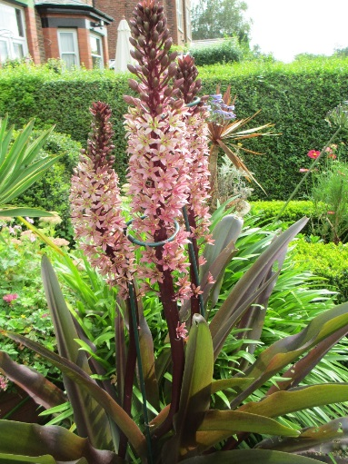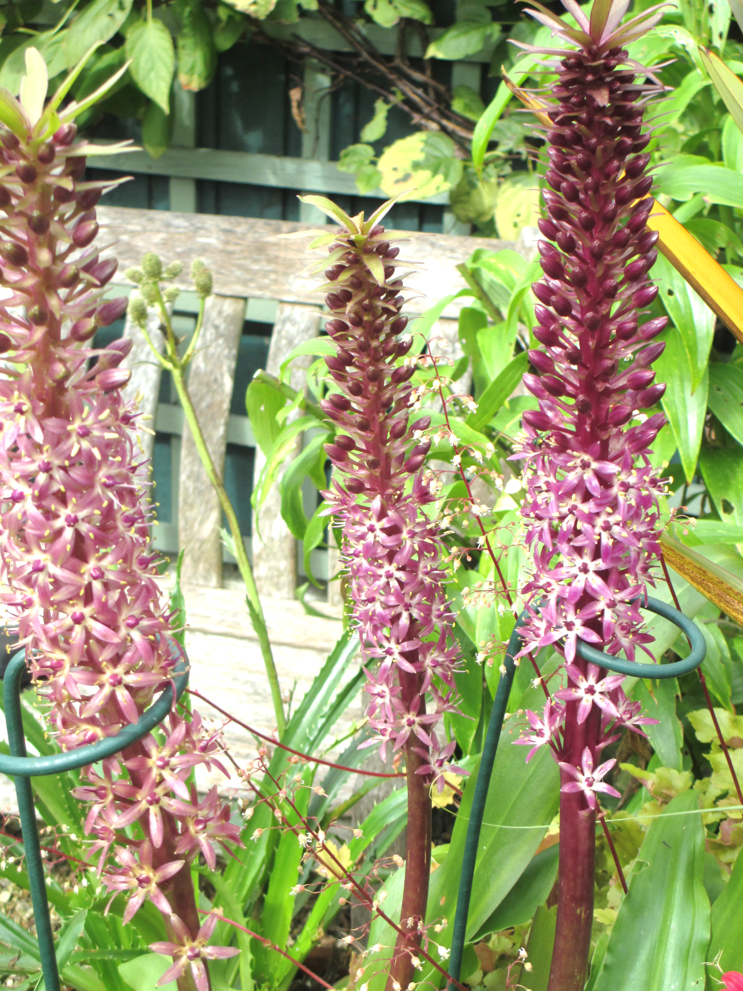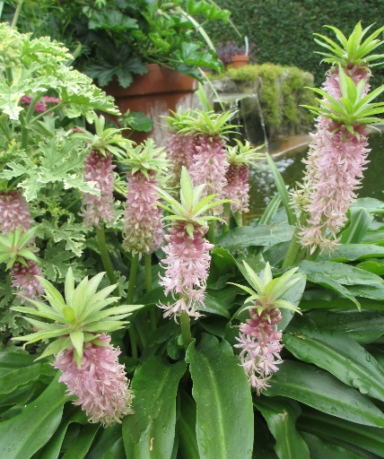
Eucomis ‘Sparkling Burgundy’ Eucomis ‘Joy’s Purple’ Eucomis ‘Nani’
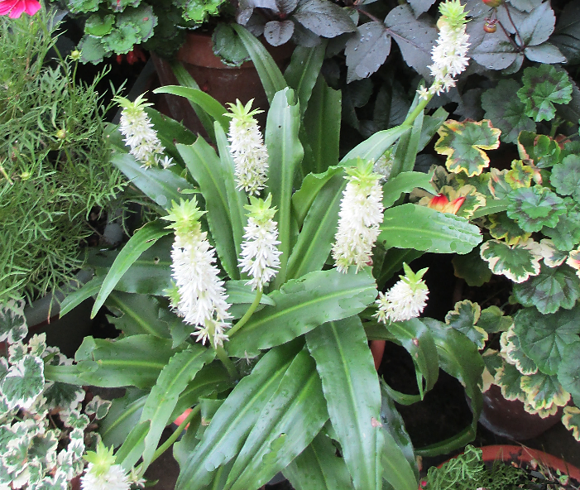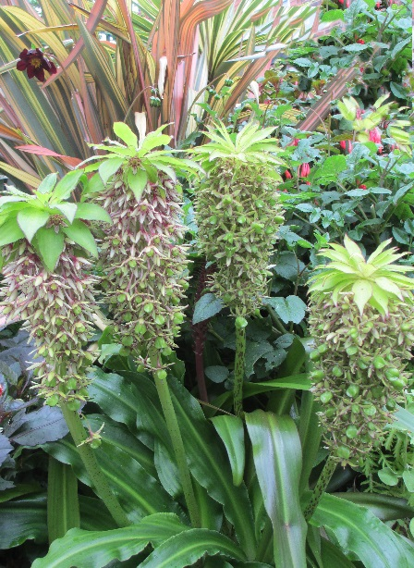
Eucomis comosa Eucomis bicolour
MUCH cheaper are Acidanthera Murielae or Gladiolus callianthus. This deliciously fragrant gladiolus is part of a genus of over 250 perennial cormous flowering plants of the iris family popularly known as ‘sword lilies’. They are very easy to grow in well - watered multipurpose compost. It is a corm really and can be saved and stored in a dry place when they have finished flowering. If you wish to do this plant them in spring to give the corms a chance to get into growth otherwise they may not flower before the first autumn frosts. If buying them in each year look for plump, good sized corms. They can be planted in quite small pots (see image) I use these lovely flowers to fill gaps in the border during late season and for cut flowers. The hybrid gladiolus are known for being big, bold and brash. The have their uses as very good, long lasting cut flowers (I wish I could find a way to use them well in a border) but there are smaller, more delicate species. Gladiolus byzantinus is such a plant for the border. Acid pink in colour and growing to 0.5 m tall it flowers in early summer. Gladiolus cardinalis, the ‘waterfall gladiolus’ is 70cm high and red with white markings on the inner part of its flowers. Gladiolus tristis is yellow and Gladiolus ‘The Bride’ is (not surprisingly) white. All are lovely! They all need free draining good soil in full sun. When placing, plant them DEEP or put some ‘scrunched up’ chicken wire on top of the bulbs to stop squirrels digging them up! They are NOT as cheap as Acidanthera!

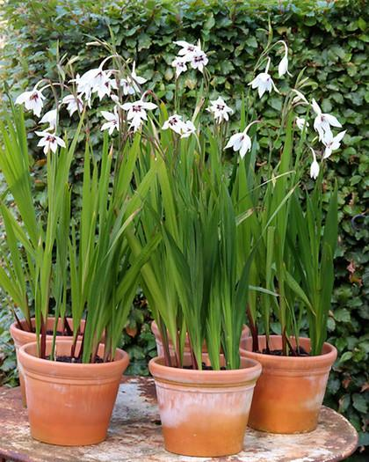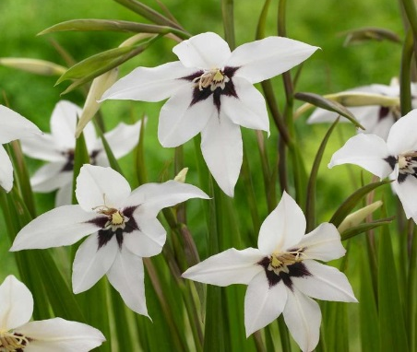
Gladiolus callianthus
Another favourite and well used bulb is the Allium. Many varieties flower during late spring but here are several high and late summer flowering ones to try. Allium narcissiflorum is a European species of wild onion. It is a beautiful alpine and clump forming species These look charming in a pot in my Mediterranean Garden but will grow very well in free draining (but not dry) soil. We are all familiar with chives (Allium schoenprasum) but why not try growing garlic chives (Allium tuberosum) too? These are taller and more robust growers and of course can be cut and used in cooking.
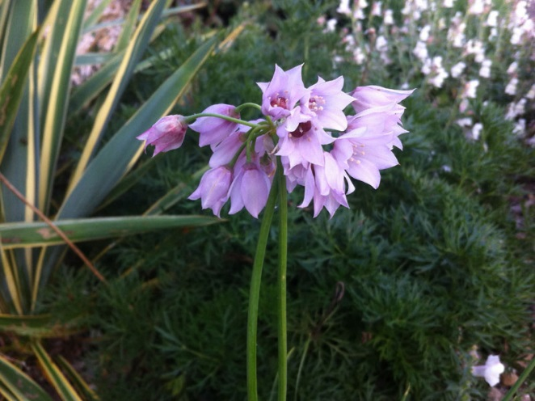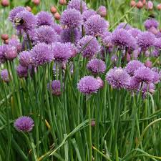
Allium narcissiflorum Allium schoenprasum
All alliums make very good companion plants for growing alongside apples, brassicas, tomatoes and strawberries because they deter aphids, spider mites and carrot fly. Some alliums (Garlic) will also deter slugs and snails! For late season interest I grow the small drumstick Allium sphaerocephalon. These are very easily cultivated in a sunny site in well - drained soil and will seed around if happy. Mine have to my great delight and now hundreds of them punctuate the borders in the Mediterranean Garden. They also look wonderful coming through Limonium latifolium at the front of the border or mixing with other see- through plants such as Lychnis, Gaura, Perovskia (now Salvia) or soft grasses.

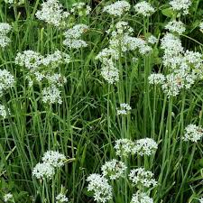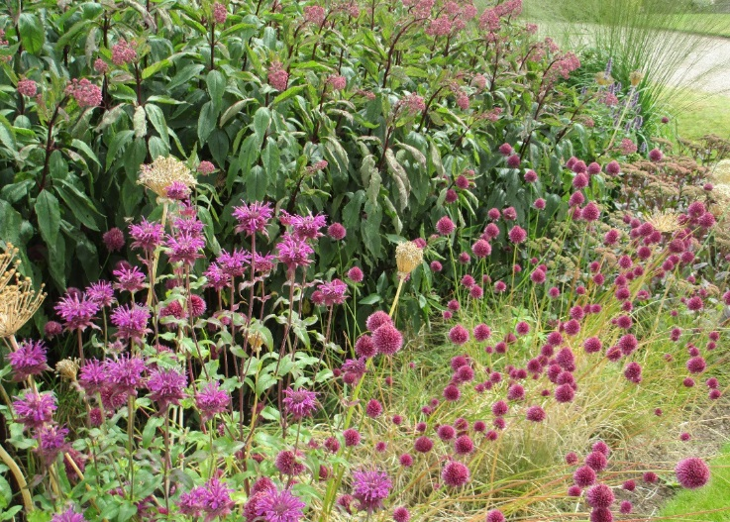
Allium tuberosum Allium shraerocephalon with Monardas

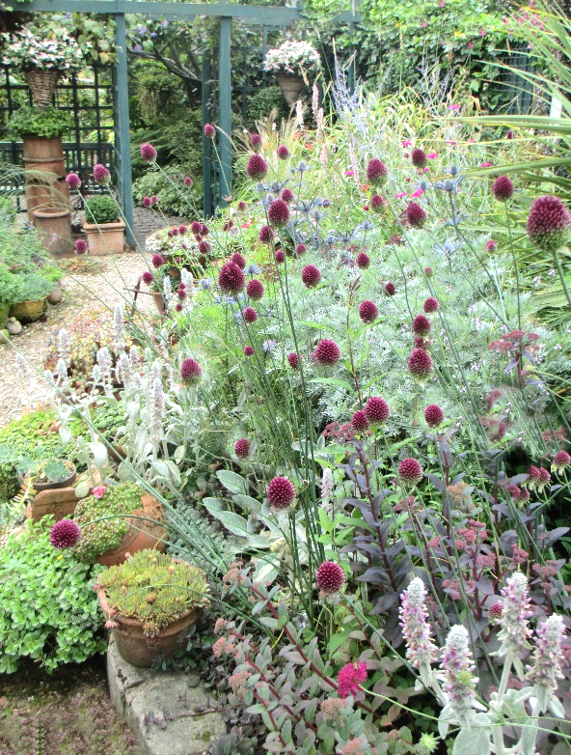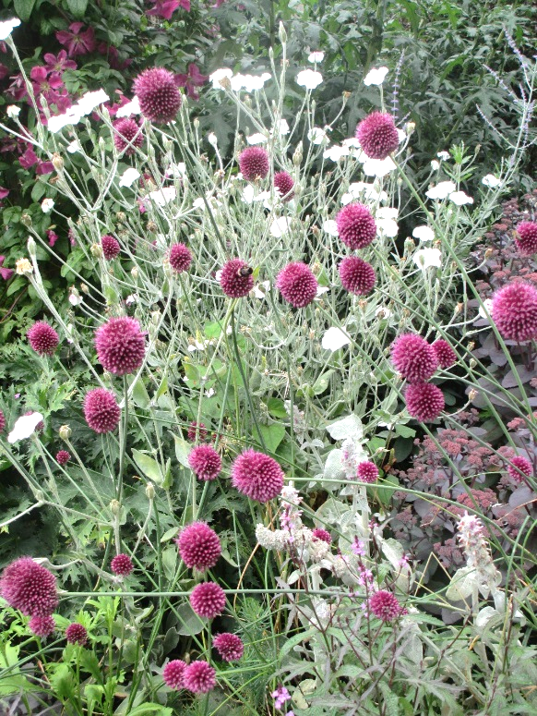
Alliums with Artemisia ‘Powis Castle’ Alliums with white Lychnis Conararia.
All these bulbs are doing very well at the moment because (as I write) the weather is hot. Of course I will have to water the pots along with all the others I am now ‘collecting’ on the terrace to eventually arrange into something coherent. The space I have is not large but I always make the most of it in summer using colourful annuals and bulbs. On Tuesday August 18th Sally Robinson will be talking to our society about ‘Big Ideas, Small Spaces’. I don’t know if she is going to include the use of pots in her presentation but it will be interesting to find out! Whether your space is large or small, watering and deadheading are is a key tasks for summer to keep the show going. Hanging baskets may need watering twice a day. Dahlias can be planted and staked now and all borders will need weeding. If you grow vegetables, you can still plant peas, carrots, swede, beetroot and leeks. In the greenhouse, keep watering crops well and damp down the space to maintain reasonably cool conditions during very hot weather. Prune vines by removing growing tips. Mow the lawn but don’t cut it too short to ensure it doesn’t dry out. Lawns will recover after hot weather when it rains. Conversely, keep any ponds topped up! I avoid working in very hot sun and wait until cooler conditions come during the evening when it is much more pleasant. Try to take time out to visit Chorley Flower Show on 31st July – 2nd August which promises to be a lively event for all Chorley residents. If you wish to enter the amateur growing competitions this year, remember you will need to do this on-line now. The easiest way to find it is to google Chorleyflowershow.com/amateur competitions entry forms. If you are worried about filling in the form or do not often use a computer, ask someone you know to help you. Good luck!
Have a happy gardening summer
Moe

